PROGRAMMING 2B (PROG6212)
St10478134
Reitumetse Helepi
[Year]
RaceDay Event Management System - Part 1: System Planning and Database
Contents
Section A: Entity Relationship Diagram (ERD) 2
Section B: API Endpoint Plan 6
Section C SQL 17
Github and References 28

Section A: Entity Relationship Diagram (ERD)
Entity Descriptions
The RaceDay system meets the minimum criterion of six entities with the following seven (7) entities:
Entity | Description
Users | keeps track of every user account. Every user has a role, such as participant or organizer.
Roles | User role lookup table (Organizer, Participant).
Events | keeps track of event information, such as name, description, date, location, distance, and event type.
Categories | establishes age or distance divisions for every event (e.g., Under 20, Senior, 10km, 21km).
EventCategories | Events and categories are connected by a junction table (many-to-many relationship).
Enrolments | Enrolments of participants in particular events are recorded under designated categories.
Results | After an event is over, participants' finish times and positions are stored.

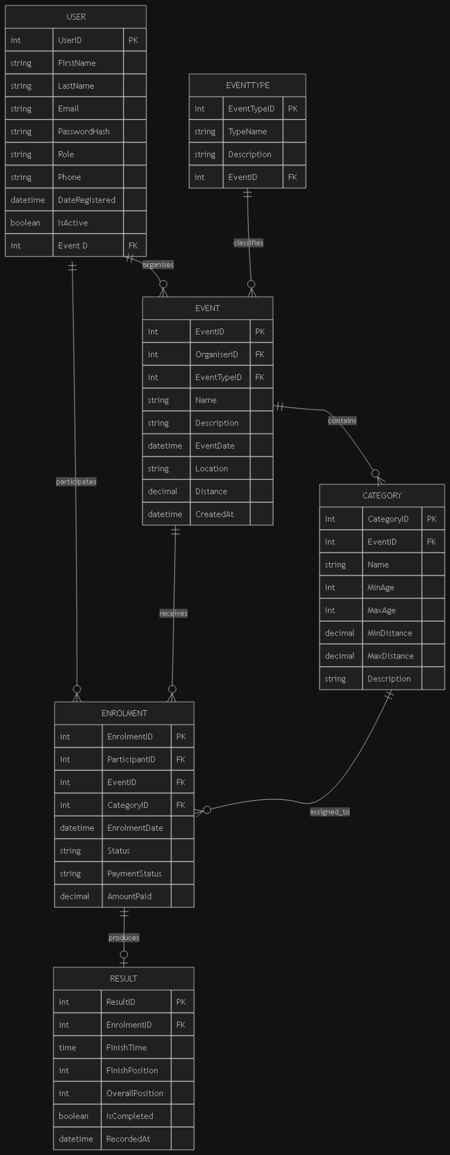 (draw.io)
Cardinality Explanation
Relationship | Cardinality | Explanation
Users - Roles | Many-to-One | Each user has one role; each role can have many users
Users - Enrolments | One-to-Many | A Participant can have many enrolments; each enrolment belongs to one user (Participant)
Users - Events | One-to-Many | An Organiser can create many events; each event belongs to one Organiser
Events - Enrolments | One-to-Many | An event can have many enrolments; each enrolment is for one event
Events - EventCategories | One-to-Many | An event can have many categories; each EventCategory links one event to one category
Categories - EventCategories | One-to-Many | A category can be linked to many events; each EventCategory links one category to one event
Enrolments - Results | One-to-One | Each enrolment can have zero or one result; each result belongs to one enrolment
Enrolments - Categories | Many-to-One | Each enrolment selects one category; a category can be selected by many enrolments

Primary and Foreign Keys
Entity | Primary Key | Foreign Key(s)
Users | UserId | RoleId - Roles.RoleId
Roles | RoleId | -
Events | EventId | OrganiserId - Users.UserId
Categories | CategoryId | -
EventCategories | EventCategoryId (composite: EventId + CategoryId) | EventId - Events.EventId; CategoryId - Categories.CategoryId
Enrolments | EnrolmentId | ParticipantId - Users.UserId; EventId - Events.EventId; CategoryId - Categories.CategoryId
Results | ResultId | EnrolmentId - Enrolments.EnrolmentId

Section B: API Endpoint Plan
Base URL:/api
Authentication Endpoints
HTTP Method | Route | Description | Role Required | Request Body | Expected Response
POST | /auth/register | Register a new user account with role selection (Organiser or Participant) | None (Public) | { email, password, firstName, lastName, role } | 201 Created -{ userId, email, role }400 Bad Request - validation error 409 Conflict - email already exists
POST | /auth/login | Authenticate a user and establish a session | None (Public) | { email, password } | 200 OK -{ userId, email, role, firstName, lastName }401 Unauthorized - invalid credentials

User Profile Endpoints
HTTP Method | Route | Description | Role Required | Request Body | Expected Response
GET | /users/profile | Get the currently authenticated user's profile | Any (Logged in) | None | 200 OK -{ userId, email, firstName, lastName, role, profilePictureUrl, createdAt }401 Unauthorized - not authenticated
PUT | /users/profile | Update the authenticated user's profile information | Any (Logged in) | { firstName, lastName, email } | 200 OK - updated user profile 400 Bad Request - validation error 401 Unauthorized - not authenticated
POST | /users/profile/picture | Upload a profile picture for the authenticated user | Any (Logged in) | Multipart form data:{ profilePicture } | 200 OK -{ profilePictureUrl }400 Bad Request - invalid file 401 Unauthorized - not authenticated

Event Endpoints
HTTP Method | Route | Description | Role Required | Request Body | Expected Response
GET | /events | Get all events with optional filtering | Any (Logged in) | None (query params: type, dateFrom, dateTo) | 200 OK array of event objects 401 Unauthorized not authenticated
GET | /events/{id} | Get a specific event by ID | Any (Logged in) | None | 200 OK event object with categories 404 Not Found event does not exist 401 Unauthorized not authenticated
POST | /events | Create a new event | Organiser | { name, description, eventDate, location, distance, eventType, bannerImage? } | 201 Created - created event 400 Bad Request - validation error 401 Unauthorized - not authenticated 403 Forbidden - not an Organiser
PUT | /events/{id} | Update an existing event | Organiser | { name, description, eventDate, location, distance, eventType, bannerImage? } | 200 OK - updated event 400 Bad Request - validation error 401 Unauthorized - not authenticated 403 Forbidden - not the event owner 404 Not Found - event does not exist
DELETE | /events/{id} | Delete an event | Organiser | None | 204 No Content 401 Unauthorized - not authenticated 403 Forbidden - not the event owner 404 Not Found - event does not exist
POST | /events/{id}/banner | Upload a banner image for an event | Organiser | Multipart form data:{ bannerImage } | 200 OK -{ bannerImageUrl }400 Bad Request - invalid file 401 Unauthorized - not authenticated 403 Forbidden - not the event owner

Category Endpoints
HTTP Method | Route | Description | Role Required | Request Body | Expected Response
GET | /categories | Get all categories | Any (Logged in) | None | 200 OK - array of category objects 401 Unauthorized - not authenticated
GET | /categories/{id} | Get a specific category by ID | Any (Logged in) | None | 200 OK - category object 404 Not Found - category does not exist 401 Unauthorized - not authenticated
POST | /categories | Create a new category | Organiser | { name, description, categoryType } | 201 Created - created category 400 Bad Request - validation error 401 Unauthorized - not authenticated 403 Forbidden - not an Organiser
PUT | /categories/{id} | Update an existing category | Organiser | { name, description, categoryType } | 200 OK - updated category 400 Bad Request - validation error 401 Unauthorized - not authenticated 403 Forbidden - not an Organiser 404 Not Found - category does not exist
DELETE | /categories/{id} | Delete a category | Organiser | None | 204 No Content 401 Unauthorized - not authenticated 403 Forbidden - not an Organiser 404 Not Found - category does not exist
POST | /events/{eventId}/categories/{categoryId} | Add a category to an event | Organiser | None | 201 Created - link created 401 Unauthorized - not authenticated 403 Forbidden - not the event owner 404 Not Found - event or category does not exist
DELETE | /events/{eventId}/categories/{categoryId} | Remove a category from an event | Organiser | None | 204 No Content 401 Unauthorized - not authenticated 403 Forbidden - not the event owner 404 Not Found - event or category does not exist

Event Enrolment Endpoints
HTTP Method | Route | Description | Role Required | Request Body | Expected Response
GET | /enrolments | Get all enrolments for the authenticated user (Participant) or all enrolments for Organiser's events | Any (Logged in) | None | 200 OK - array of enrolment objects 401 Unauthorized - not authenticated
GET | /enrolments/{id} | Get a specific enrolment by ID | Any (Logged in) | None | 200 OK - enrolment object 404 Not Found - enrolment does not exist 401 Unauthorized - not authenticated 403 Forbidden - not the participant or organiser
POST | /enrolments | Enrol a Participant in an event with a selected category | Participant | { eventId, categoryId } | 201 Created - enrolment object 400 Bad Request - validation error or already enrolled 401 Unauthorized - not authenticated 403 Forbidden - not a Participant 404 Not Found - event or category does not exist
PUT | /enrolments/{id}/status | Update enrolment status (for Organisers) | Organiser | { status } | 200 OK - updated enrolment 400 Bad Request - invalid status 401 Unauthorized - not authenticated 403 Forbidden - not the event organiser 404 Not Found - enrolment does not exist
GET | /events/{eventId}/enrolments | Get all enrolments for a specific event | Organiser | None | 200 OK - array of enrolment objects with participant details 401 Unauthorized - not authenticated 403 Forbidden - not the event organiser 404 Not Found - event does not exist

Result Endpoints
HTTP Method | Route | Description | Role Required | Request Body | Expected Response
GET | /results/my | Get all results for the authenticated Participant | Participant | None | 200 OK - array of result objects with event details 401 Unauthorized - not authenticated 403 Forbidden - not a Participant
GET | /events/{eventId}/results | Get all results for a specific event | Any (Logged in) | None | 200 OK - array of result objects 401 Unauthorized - not authenticated 404 Not Found - event does not exist
POST | /results | Capture a result for an enrolled Participant (finish time and position) | Organiser | { enrolmentId, finishTime, finishingPosition } | 201 Created - result object 400 Bad Request - validation error or result already exists 401 Unauthorized - not authenticated 403 Forbidden - not the event organiser 404 Not Found - enrolment does not exist
PUT | /results/{id} | Update an existing result | Organiser | { finishTime, finishingPosition } | 200 OK - updated result 400 Bad Request - validation error 401 Unauthorized - not authenticated 403 Forbidden - not the event organiser 404 Not Found - result does not exist
DELETE | /results/{id} | Delete a result | Organiser | None | 204 No Content 401 Unauthorized - not authenticated 403 Forbidden - not the event organiser 404 Not Found - result does not exist

Section C SQL
-- 1. CREATE DATABASE

CREATE DATABASE RaceDayDB;
GO

USE RaceDayDB;
GO
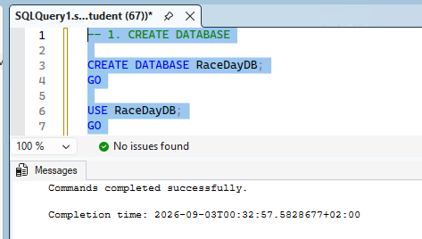

-- 2. CREATE TABLES
-- 2.1 Roles Table (Lookup)
CREATE TABLE Roles (
RoleId INT IDENTITY(1,1) PRIMARY KEY,
RoleName NVARCHAR(50) NOT NULL UNIQUE,
Description NVARCHAR(200) NULL,
CreatedAt DATETIME DEFAULT GETDATE()
);
GO

-- 2.2 Users Table
CREATE TABLE Users (
UserId INT IDENTITY(1,1) PRIMARY KEY,
Email NVARCHAR(100) NOT NULL UNIQUE,
PasswordHash NVARCHAR(255) NOT NULL,
FirstName NVARCHAR(50) NOT NULL,
LastName NVARCHAR(50) NOT NULL,
RoleId INT NOT NULL,
ProfilePictureUrl NVARCHAR(500) NULL,
CreatedAt DATETIME DEFAULT GETDATE(),
CONSTRAINT FK_Users_Roles FOREIGN KEY (RoleId) REFERENCES Roles(RoleId),
CONSTRAINT CHK_Users_Email CHECK (Email LIKE '%_@__%.__%')
);
GO

-- 2.3 Events Table
CREATE TABLE Events (
EventId INT IDENTITY(1,1) PRIMARY KEY,
OrganiserId INT NOT NULL,
Name NVARCHAR(100) NOT NULL,
Description NVARCHAR(500) NULL,
EventDate DATETIME NOT NULL,
Location NVARCHAR(200) NOT NULL,
Distance DECIMAL(8,2) NOT NULL,
EventType NVARCHAR(20) NOT NULL CHECK (EventType IN ('Run', 'Walk', 'Cycle')),
BannerImageUrl NVARCHAR(500) NULL,
CreatedAt DATETIME DEFAULT GETDATE(),
CONSTRAINT FK_Events_Users FOREIGN KEY (OrganiserId) REFERENCES Users(UserId)
);
GO

-- 2.4 Categories Table
CREATE TABLE Categories (
CategoryId INT IDENTITY(1,1) PRIMARY KEY,
Name NVARCHAR(50) NOT NULL,
Description NVARCHAR(200) NULL,
CategoryType NVARCHAR(20) NOT NULL CHECK (CategoryType IN ('Age', 'Distance')),
CreatedAt DATETIME DEFAULT GETDATE()
);
GO

-- 2.5 EventCategories Junction Table (Many-to-Many)
CREATE TABLE EventCategories (
EventCategoryId INT IDENTITY(1,1) PRIMARY KEY,
EventId INT NOT NULL,
CategoryId INT NOT NULL,
CONSTRAINT FK_EventCategories_Events FOREIGN KEY (EventId) REFERENCES Events(EventId) ON DELETE CASCADE,
CONSTRAINT FK_EventCategories_Categories FOREIGN KEY (CategoryId) REFERENCES Categories(CategoryId) ON DELETE CASCADE,
CONSTRAINT UQ_EventCategories_EventCategory UNIQUE (EventId, CategoryId)
);
GO

-- 2.6 Enrolments Table
CREATE TABLE Enrolments (
EnrolmentId INT IDENTITY(1,1) PRIMARY KEY,
ParticipantId INT NOT NULL,
EventId INT NOT NULL,
CategoryId INT NOT NULL,
EnrolmentDate DATETIME DEFAULT GETDATE(),
Status NVARCHAR(20) NOT NULL DEFAULT 'Pending' CHECK (Status IN ('Pending', 'Confirmed', 'Cancelled', 'Completed')),
CONSTRAINT FK_Enrolments_Users FOREIGN KEY (ParticipantId) REFERENCES Users(UserId),
CONSTRAINT FK_Enrolments_Events FOREIGN KEY (EventId) REFERENCES Events(EventId) ON DELETE CASCADE,
CONSTRAINT FK_Enrolments_Categories FOREIGN KEY (CategoryId) REFERENCES Categories(CategoryId),
CONSTRAINT UQ_Enrolments_ParticipantEvent UNIQUE (ParticipantId, EventId)
);
GO

-- 2.7 Results Table
CREATE TABLE Results (
ResultId INT IDENTITY(1,1) PRIMARY KEY,
EnrolmentId INT NOT NULL,
FinishTime TIME NOT NULL,
FinishingPosition INT NOT NULL,
CreatedAt DATETIME DEFAULT GETDATE(),
CONSTRAINT FK_Results_Enrolments FOREIGN KEY (EnrolmentId) REFERENCES Enrolments(EnrolmentId) ON DELETE CASCADE,
CONSTRAINT UQ_Results_Enrolment UNIQUE (EnrolmentId)
);
GO
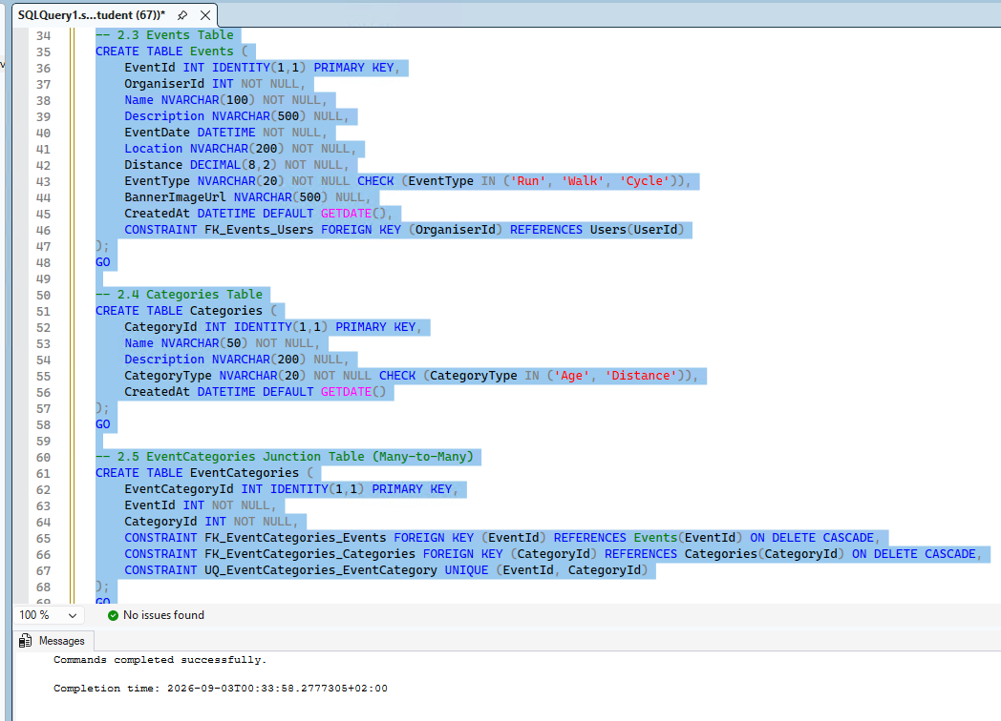
-- 3. CREATE INDEXES FOR PERFORMANCE

CREATE INDEX IX_Users_RoleId ON Users(RoleId);
CREATE INDEX IX_Users_Email ON Users(Email);
CREATE INDEX IX_Events_OrganiserId ON Events(OrganiserId);
CREATE INDEX IX_Events_EventDate ON Events(EventDate);
CREATE INDEX IX_EventCategories_EventId ON EventCategories(EventId);
CREATE INDEX IX_EventCategories_CategoryId ON EventCategories(CategoryId);
CREATE INDEX IX_Enrolments_ParticipantId ON Enrolments(ParticipantId);
CREATE INDEX IX_Enrolments_EventId ON Enrolments(EventId);
CREATE INDEX IX_Enrolments_CategoryId ON Enrolments(CategoryId);
CREATE INDEX IX_Enrolments_Status ON Enrolments(Status);
CREATE INDEX IX_Results_EnrolmentId ON Results(EnrolmentId);
GO
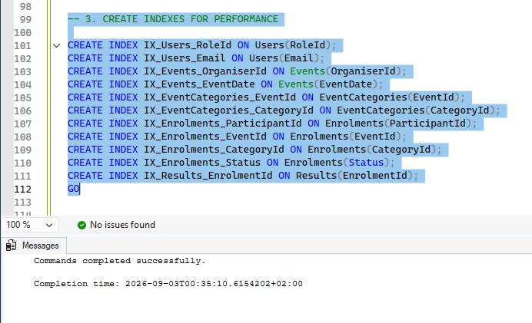

-- 4. SEED DATA
-- 4.1 Seed Roles
INSERT INTO Roles (RoleName, Description) VALUES
('Organiser', 'Event organiser who can create and manage events, categories, and results'),
('Participant', 'Event participant who can browse events, enrol, and view results');
GO

-- 4.2 Seed Users (Passwords are hashed - using placeholder hashes for demonstration)
-- Note: In production, passwords would be properly hashed using bcrypt or ASP.NET Core Identity
INSERT INTO Users (Email, PasswordHash, FirstName, LastName, RoleId, ProfilePictureUrl) VALUES
('thabo.mokoena@raceday.co.za', 'hashed_password_1', 'Thabo', 'Mokoena', 1, NULL),
('linda.zulu@raceday.co.za', 'hashed_password_2', 'Linda', 'Zulu', 1, NULL),
('sipho.ndlovu@gmail.com', 'hashed_password_3', 'Sipho', 'Ndlovu', 2, NULL),
('zanele.dlamini@gmail.com', 'hashed_password_4', 'Zanele', 'Dlamini', 2, NULL);
GO

-- 4.3 Seed Categories
INSERT INTO Categories (Name, Description, CategoryType) VALUES
('Under 20', 'Participants aged under 20 years', 'Age'),
('Senior (20-39)', 'Participants aged 20 to 39 years', 'Age'),
('Master (40+)', 'Participants aged 40 years and over', 'Age'),
('10km', '10 kilometre distance category', 'Distance'),
('21km', '21.1 kilometre half-marathon category', 'Distance'),
('42km', '42.2 kilometre marathon category', 'Distance');
GO

-- 4.4 Seed Events
INSERT INTO Events (OrganiserId, Name, Description, EventDate, Location, Distance, EventType, BannerImageUrl) VALUES
(1, 'Soweto Marathon', 'Annual Soweto Marathon through the streets of Soweto', '2026-09-15 06:00:00', 'Soweto, Johannesburg', 42.20, 'Run', NULL),
(1, 'Cape Town Cycle Tour', 'World-famous Cape Town Cycle Tour', '2026-10-20 07:00:00', 'Cape Town', 109.00, 'Cycle', NULL),
(2, 'Two Oceans Marathon', 'Ultra-marathon with stunning coastal views', '2026-11-05 05:30:00', 'Cape Town', 56.00, 'Run', NULL);
GO

-- 4.5 Link Events to Categories (EventCategories)
INSERT INTO EventCategories (EventId, CategoryId) VALUES
-- Soweto Marathon categories
(1, 1), (1, 2), (1, 3), (1, 6),
-- Cape Town Cycle Tour categories
(2, 1), (2, 2), (2, 3),
-- Two Oceans Marathon categories
(3, 1), (3, 2), (3, 3), (3, 5);
GO

-- 4.6 Seed Enrolments
INSERT INTO Enrolments (ParticipantId, EventId, CategoryId, Status) VALUES
(3, 1, 2, 'Confirmed'),
(3, 2, 1, 'Pending'),
(4, 1, 3, 'Confirmed'),
(4, 3, 2, 'Pending');
GO

-- 4.7 Seed Results
INSERT INTO Results (EnrolmentId, FinishTime, FinishingPosition) VALUES
(1, '03:45:12', 47),
(3, '04:12:08', 89);
GO
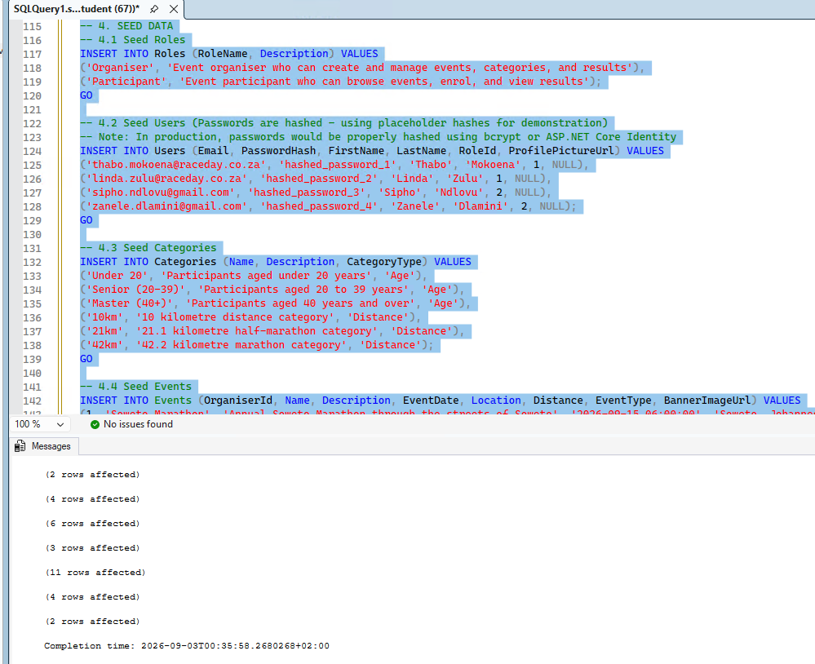

-- 5. VERIFICATION QUERIES

-- Verify all tables have been created
SELECT TABLE_NAME FROM INFORMATION_SCHEMA.TABLES WHERE TABLE_TYPE = 'BASE TABLE';
GO

-- Verify seed data
SELECT * FROM Roles;
SELECT * FROM Users;
SELECT * FROM Categories;
SELECT * FROM Events;
SELECT * FROM EventCategories;
SELECT * FROM Enrolments;
SELECT * FROM Results;
GO
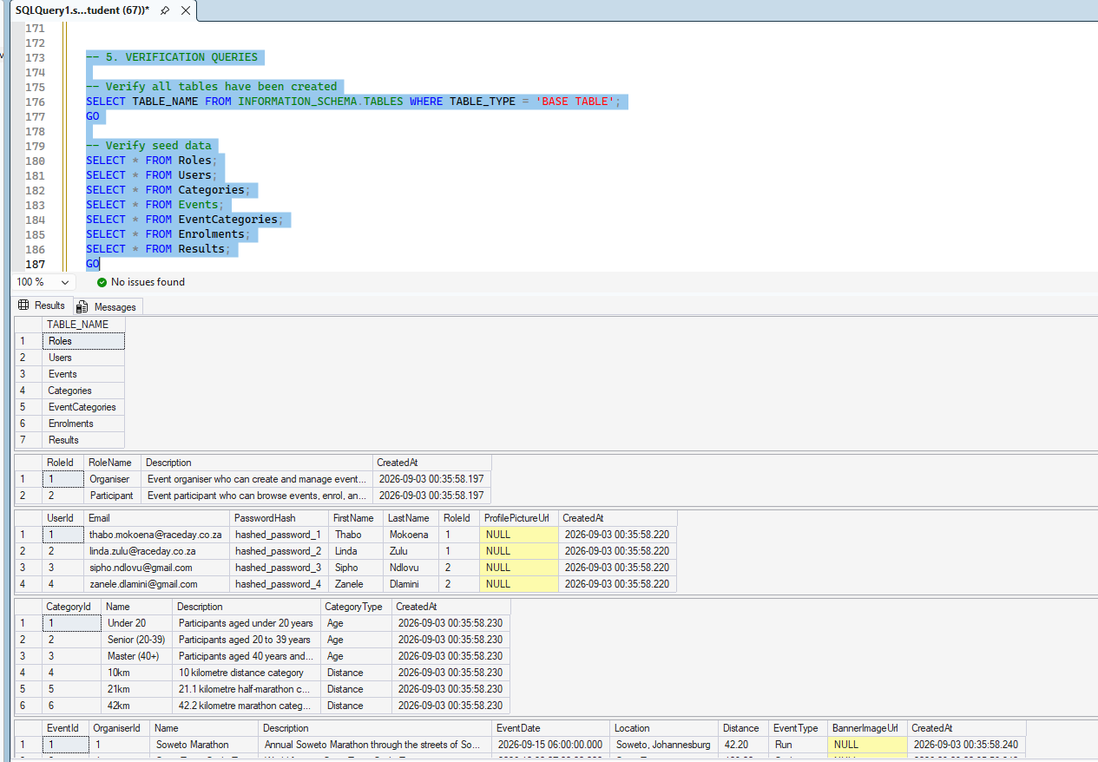

Github and References
Reitumetse134/RaceDayDB
https://github.com/Reitumetse134/RaceDayDB
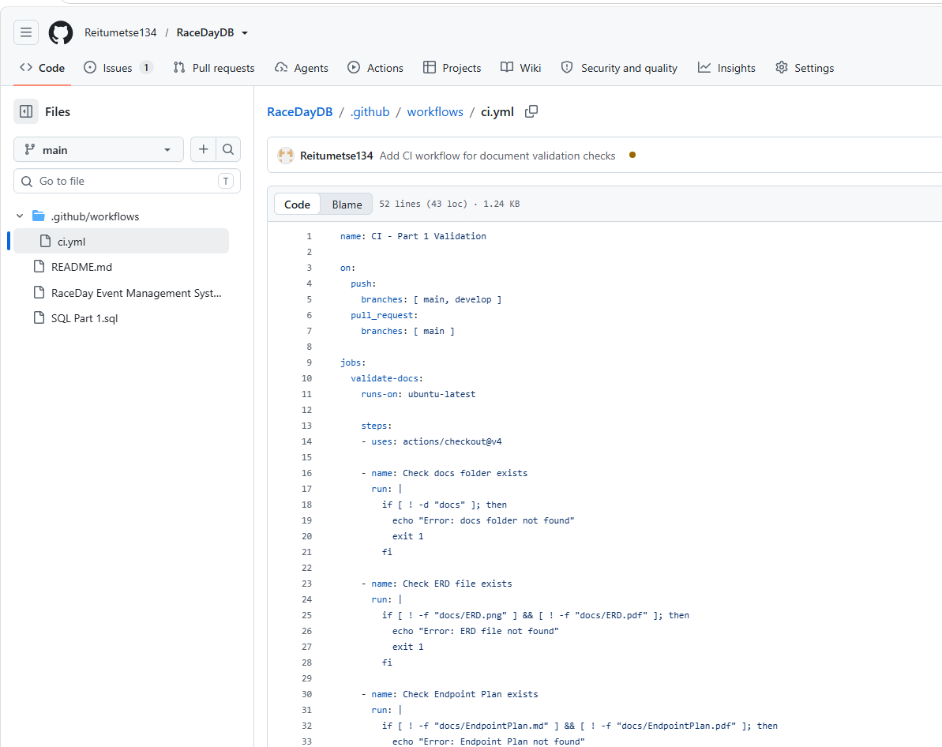
name: CI - Part 1 Validation

on:
push:
branches: [ main, develop ]
pull_request:
branches: [ main ]

jobs:
validate-docs:
runs-on: ubuntu-latest

steps:
- uses: actions/checkout@v4

- name: Check docs folder exists
run: |
if [ ! -d "docs" ]; then
echo "Error: docs folder not found"
exit 1
fi

- name: Check ERD file exists
run: |
if [ ! -f "docs/ERD.png" ] && [ ! -f "docs/ERD.pdf" ]; then
echo "Error: ERD file not found"
exit 1
fi

- name: Check Endpoint Plan exists
run: |
if [ ! -f "docs/EndpointPlan.md" ] && [ ! -f "docs/EndpointPlan.pdf" ]; then
echo "Error: Endpoint Plan not found"
exit 1
fi

- name: Check SQL Script exists
run: |
if [ ! -f "docs/RaceDayDB.sql" ]; then
echo "Error: SQL script not found"
exit 1
fi

- name: Validate SQL script contains CREATE statements
run: |
if ! grep -q "CREATE TABLE" docs/RaceDayDB.sql; then
echo "Error: SQL script missing CREATE TABLE statements"
exit 1
fi

- name: Success
run: echo "✅ All validation checks passed!"

Reference list
3Wschool (2025). W3Schools.Com. [online] W3schools.com. Available at: https://www.w3schools.com/sql/?utm_source=chatgpt.com [Accessed 28 Aug. 2026].
Bootstrap (2023). Get started with bootstrap. [online] getbootstrap.com. Available at: https://getbootstrap.com/docs/5.3/getting-started/introduction/ [Accessed 28 Aug. 2026].
chcomley (2026a). Azure boards documentation. [online] MicrosoftLearn. Available at: https://learn.microsoft.com/en-us/azure/devops/boards/?view=azure-devops&utm_source=chatgpt.com [Accessed 28 Aug. 2026].
chcomley (2026b). Azure DevOps documentation. [online] MicrosoftLearn. Available at: https://learn.microsoft.com/en-us/azure/devops/?view=azure-devops&utm_source=chatgpt.com [Accessed 28 Aug. 2026].
dimitri-furman (2024). Monitoring and performance tuning - azure SQL database & azure SQL managed instance. [online] MicrosoftLearn. Available at: https://learn.microsoft.com/en-us/azure/azure-sql/database/monitor-tune-overview?view=azuresql&utm_source=chatgpt.com [Accessed 28 Aug. 2026].
IBM (2024). Think topics | IBM. [online] Ibm.com. Available at: https://www.ibm.com/think/topics/agile?utm_source=chatgpt.com [Accessed 28 Aug. 2026].
pauljewellmsft (2023). Get started with Azure Blob Storage and .NET - Azure Storage. [online] learn.microsoft.com. Available at: https://learn.microsoft.com/en-us/azure/storage/blobs/storage-blob-dotnet-get-started?tabs=azure-ad [Accessed 3 Sept. 2026].
scrumguides (2025). Home | scrum guides. [online] Scrumguides.org. Available at: https://scrumguides.org/?utm_source=chatgpt.com [Accessed 28 Aug. 2026].

